**IBM URBANCODE DEPLOY & ORACLE WEBLOGIC APPLICATION DEPLOYMENT**

Contents

Installing the application: 3

Create a component 4

Create a component process 5

Create an application 8

Create a resource group 9

Create a property in resource group 9

Create an environment 10

Run Environment 11

Login to WebLogic 11

Navigate to application 12

UrbanCode Deploy has a plugin to automate activities carried out on WebLogic Server “Oracle WebLogic Application Deployment”.

To deploy an application in Oracle WebLogic using IBM UrbanCode Deploy, it is necessary to start your WebLogic.

* To start WebLogic :
  + %*Oracle_Home%\user_projects\domains\base_domain\startWebLogic.cmd*
* I then run :
  + %*Oracle_Home%\wlserver\server\bin\setWLSEnv.cmd*
* Finally I start Node Manager :
  + %*Oracle_Home%\user_projects\domains\base_domain\bin\startNodemanager.cmd*

# Installing the application:

Download some sample .war file and place it on File System as: Version1 & Version2

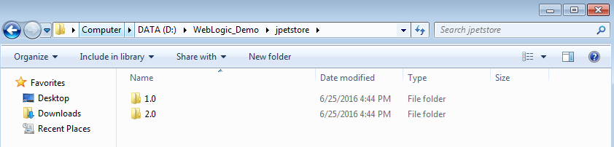

On the UrbanCode front do the following:

# Create a component

Create a *component* to add the war file and set the *Source Config Type* set to *File System (Versioned)* as *Import Versions Automatically* checked.

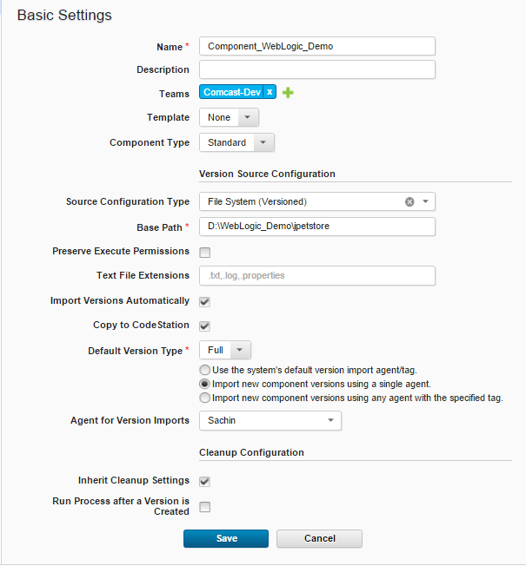

The versions will be imported automatically.

# Create a component process

Create a Component process “**Deploy**” for the Component that has two steps “*Download Artifacts*” step (default) and “*Deploy*” (WebLogic)

For deploy step enter the following:

* Deployment Name : **sample**
* Admin URL : t3://<hostnameofweblogicserver:port>
* User Name : User ( or username you set while installing WebLogic )
* Password: password for your WebLogic server
* Target: Name of your Target server
* Source : **sample.war**
* Deployment Classpath: leave it as is, we shall create property in Resource later.

The screenshots are shown below:

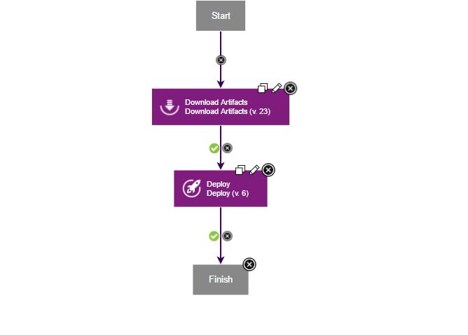

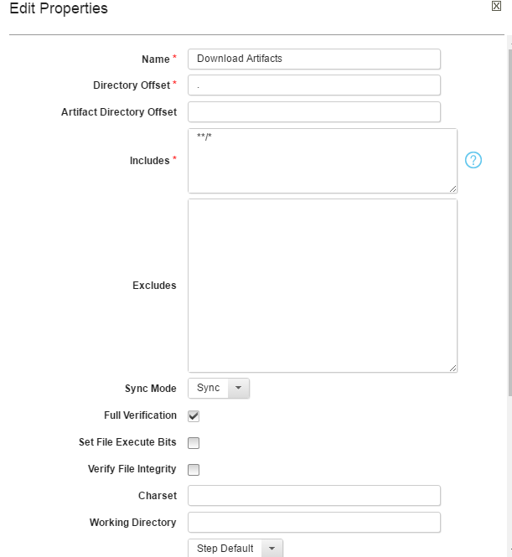

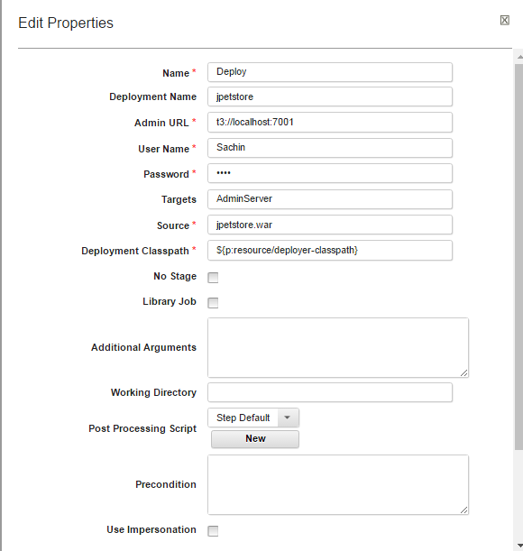

# Create an application

Create *Application*, add your *Component* to the *Application* and also create Application Process to deploy the *Component* using Component Process “*Deploy*”

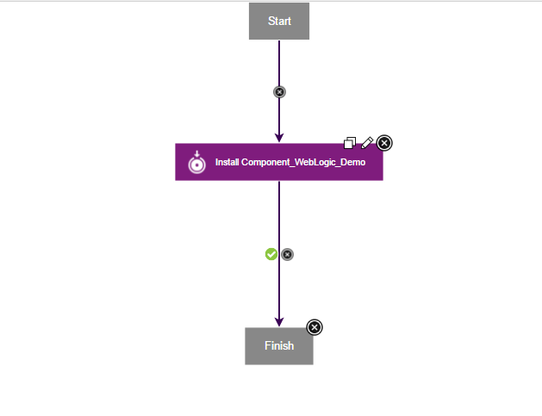

# Create a resource group

Create a *Resource Group* and add agent along with *Component* as shown below.

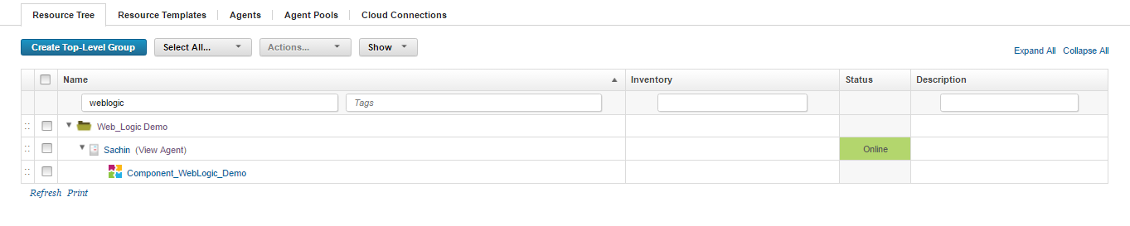

# Create a property in resource group

In *Resource Group* create property **deployer-classpath** and add path to weblogic.jar (%Oracle_Home%\wlserver\server\lib\weblogic.jar) as shown in screenshot below.

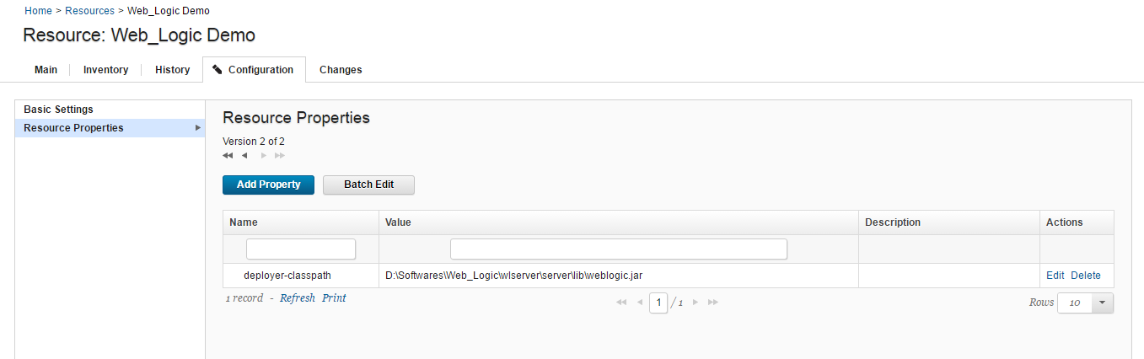

# Create an environment

In *Application*, create environment **DEV** in and add *resource group* to it.

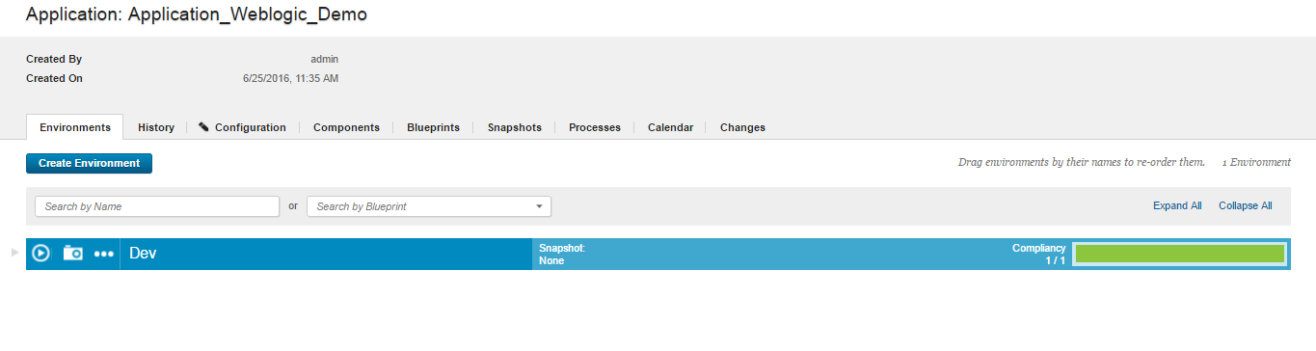

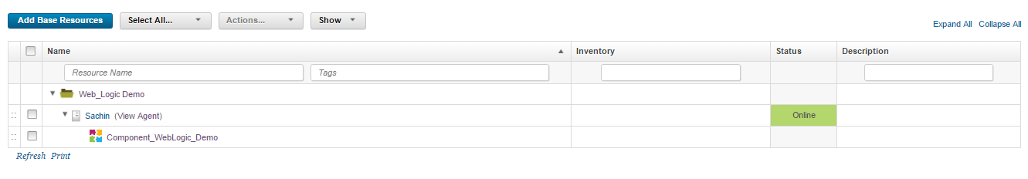

# Run Environment

We are now ready to deploy. While deploying select Version of your Component to deploy. Deployment will be successful as shown below.

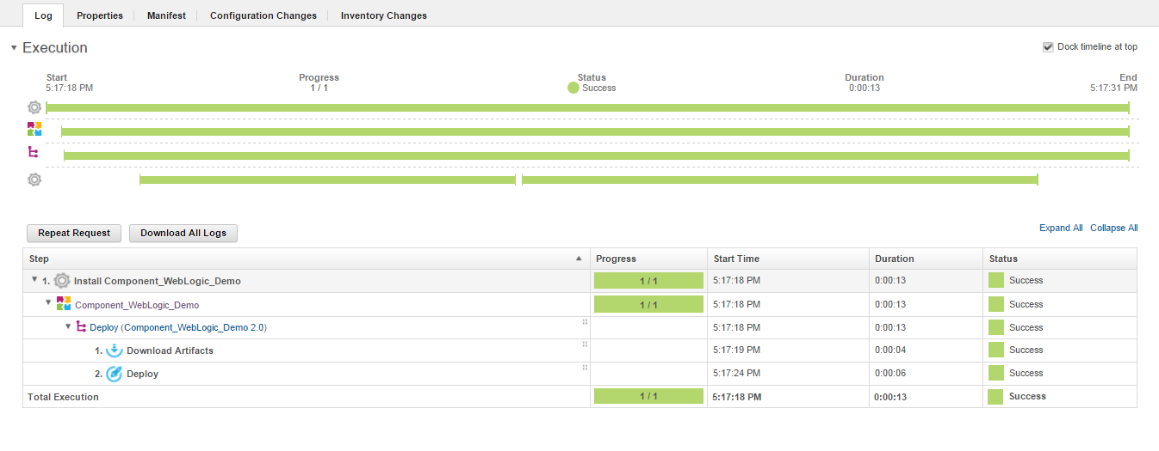

# Login to WebLogic

Login to <http://localhost:7001/console> and check same by navigating to  
base-domain->Deployments.

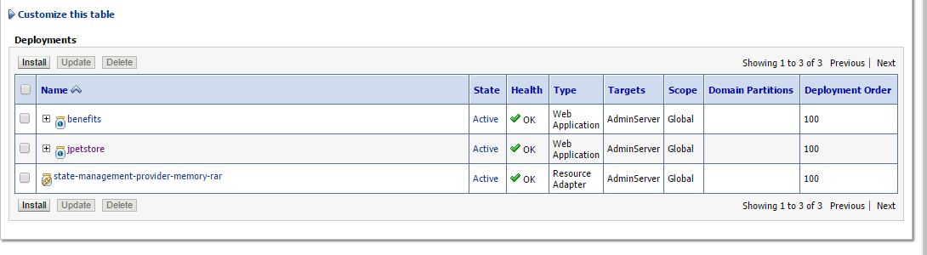

# Navigate to application

Navigate and access the application at <http://localhost:7001/sample>.

